Can’t get Dave’s stuff to work. Looking now at alternative connection possibilities

MyRIO pinout:

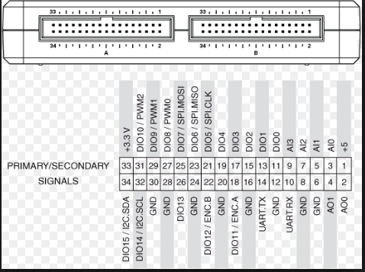

ENX 10 EASY pinout:

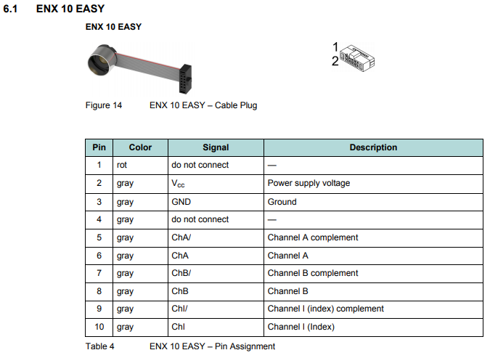

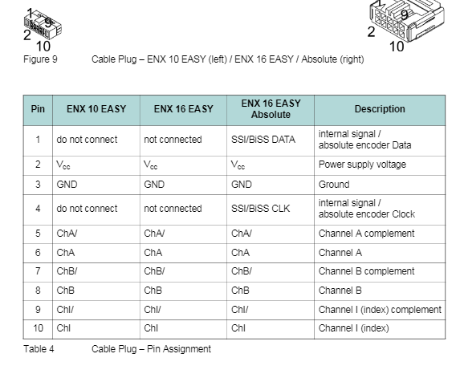

Thus, for testing:

MyRIO pin 1 to encoder pin 2: VCC (5V as per specs)

MyRIO pin 6 to encoder pin 3: GND

MyRIO pin 18 to encoder pin 6: channel A

MyRIO pin 22 to encoder pin 8: channel B.

Works.